Oral : Aviation

1 action : to limit the carbon footprint, it is necessary to set a distance limit, as you can see on the graph the shortest flights are the most polluting.

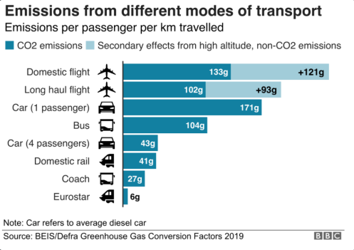

2 action : It is necessary to remove a part of the seats of the first class and business class because in a plane it is because of them that the carbon footprint is high. the seats are heavier, they take more places.

